Linear Search vs Binary Search
With Time Complexity & Graph Analysis

Name: Kirtesh Nuwal
Batch: 20
SAP ID: 590025569

UPES Dehradun

1. Introduction

Searching is one of the most fundamental operations in computer science. Whether retrieving a record from a database or locating a value in an array, the efficiency of a search algorithm directly impacts system performance. Two of the most widely studied search algorithms are Linear Search and Binary Search — each with distinct mechanisms, use cases, and time complexities.
This document provides a comprehensive comparison of both algorithms, including their working principles, time complexity analysis, performance graphs, and practical use cases.

2. Linear Search

2.1 Definition
Linear Search (also called Sequential Search) is the simplest searching algorithm. It traverses through each element of a list one by one, from the beginning to the end, until the target element is found or the list is exhausted.

2.2 How It Works
• Start from the first element (index 0).
• Compare the current element with the target value.
• If matched → return the index (success).
• If not matched → move to the next element.
• If end is reached without a match → return -1 (not found).

2.3 Time Complexity
Case | Complexity | Description
Best Case | O(1) | Target is at the first position
Average Case | O(n) | Target is somewhere in the middle
Worst Case | O(n) | Target at last position or not found

Space Complexity: O(1) — No extra memory required.

3. Binary Search

3.1 Definition
Binary Search is a highly efficient algorithm that works exclusively on sorted arrays. It repeatedly divides the search space in half, drastically reducing the number of comparisons required to find the target element.

3.2 How It Works
• Set low = 0 and high = n-1.
• Calculate mid = (low + high) / 2.
• If arr[mid] == target → found, return mid.
• If arr[mid] < target → search right half (low = mid + 1).
• If arr[mid] > target → search left half (high = mid - 1).
• Repeat until low > high → return -1 (not found).

3.3 Time Complexity
Case | Complexity | Description
Best Case | O(1) | Target is at the middle position
Average Case | O(log n) | Target found after several halvings
Worst Case | O(log n) | Target at extremes or not found

Space Complexity: O(1) iterative | O(log n) recursive (call stack).

4. Time Complexity Graph Analysis

The following graphs illustrate the performance difference between Linear Search O(n) and Binary Search O(log n) as input size increases.

4.1 O(n) vs O(log n) — Growth Rate (n up to 100)
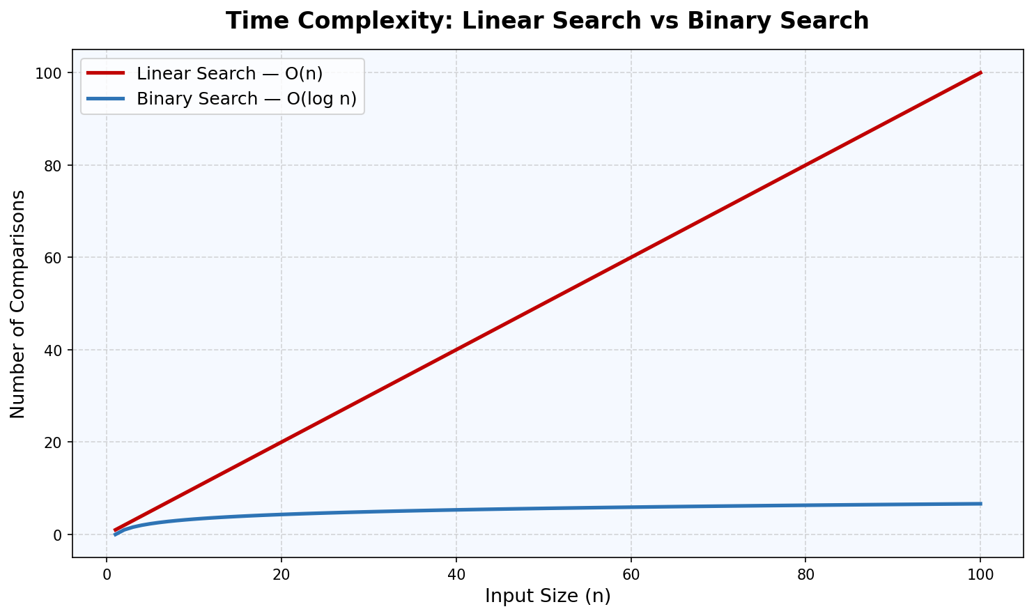
Fig 1: Linear Search grows linearly while Binary Search grows logarithmically

4.2 Large Scale Comparison (n up to 1,000,000)
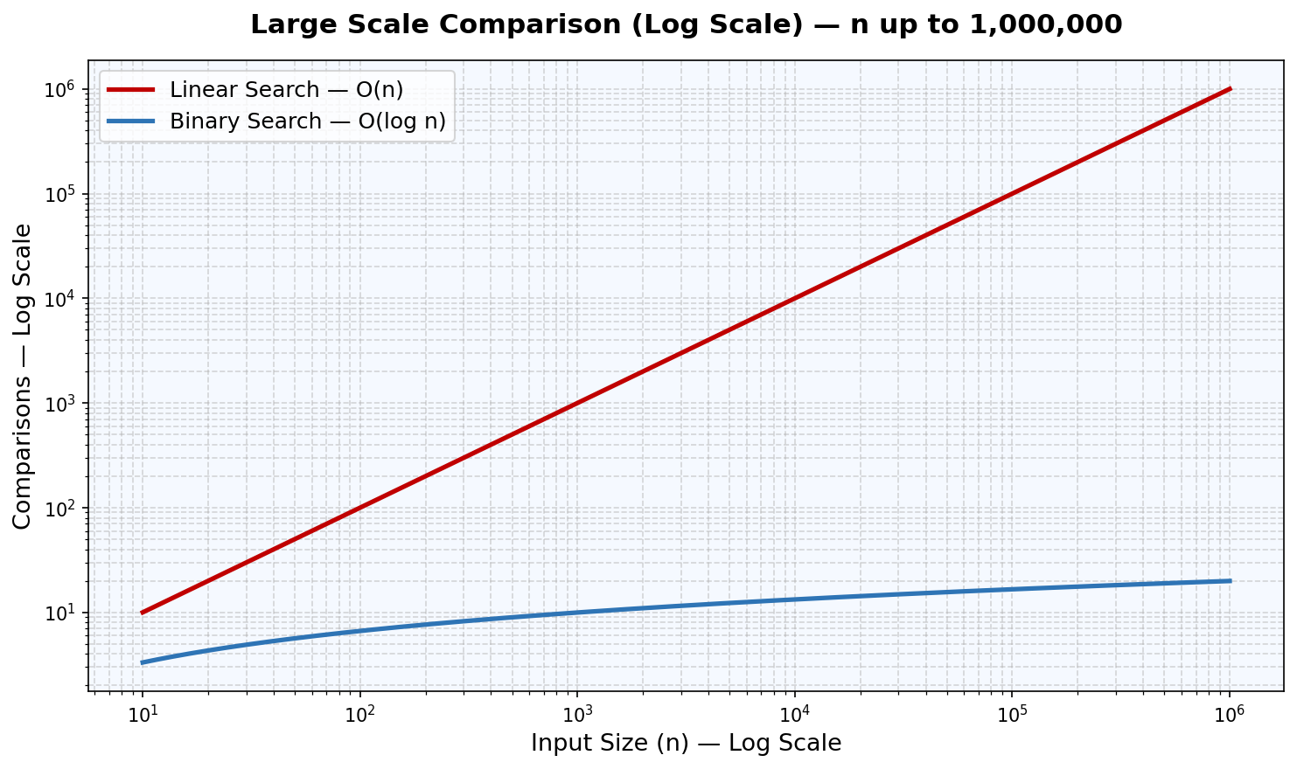
Fig 2: Log-scale view showing massive performance gap at large input sizes

4.3 Comparisons at Different Input Sizes
Input Size (n) | Linear Search O(n) | Binary Search O(log n) | Difference
10 | 10 | 4 | 2.5x faster
100 | 100 | 7 | ~14x faster
1,000 | 1,000 | 10 | 100x faster
10,000 | 10,000 | 14 | 714x faster
1,00,000 | 1,00,000 | 17 | ~5882x faster
10,00,000 | 10,00,000 | 20 | 50,000x faster

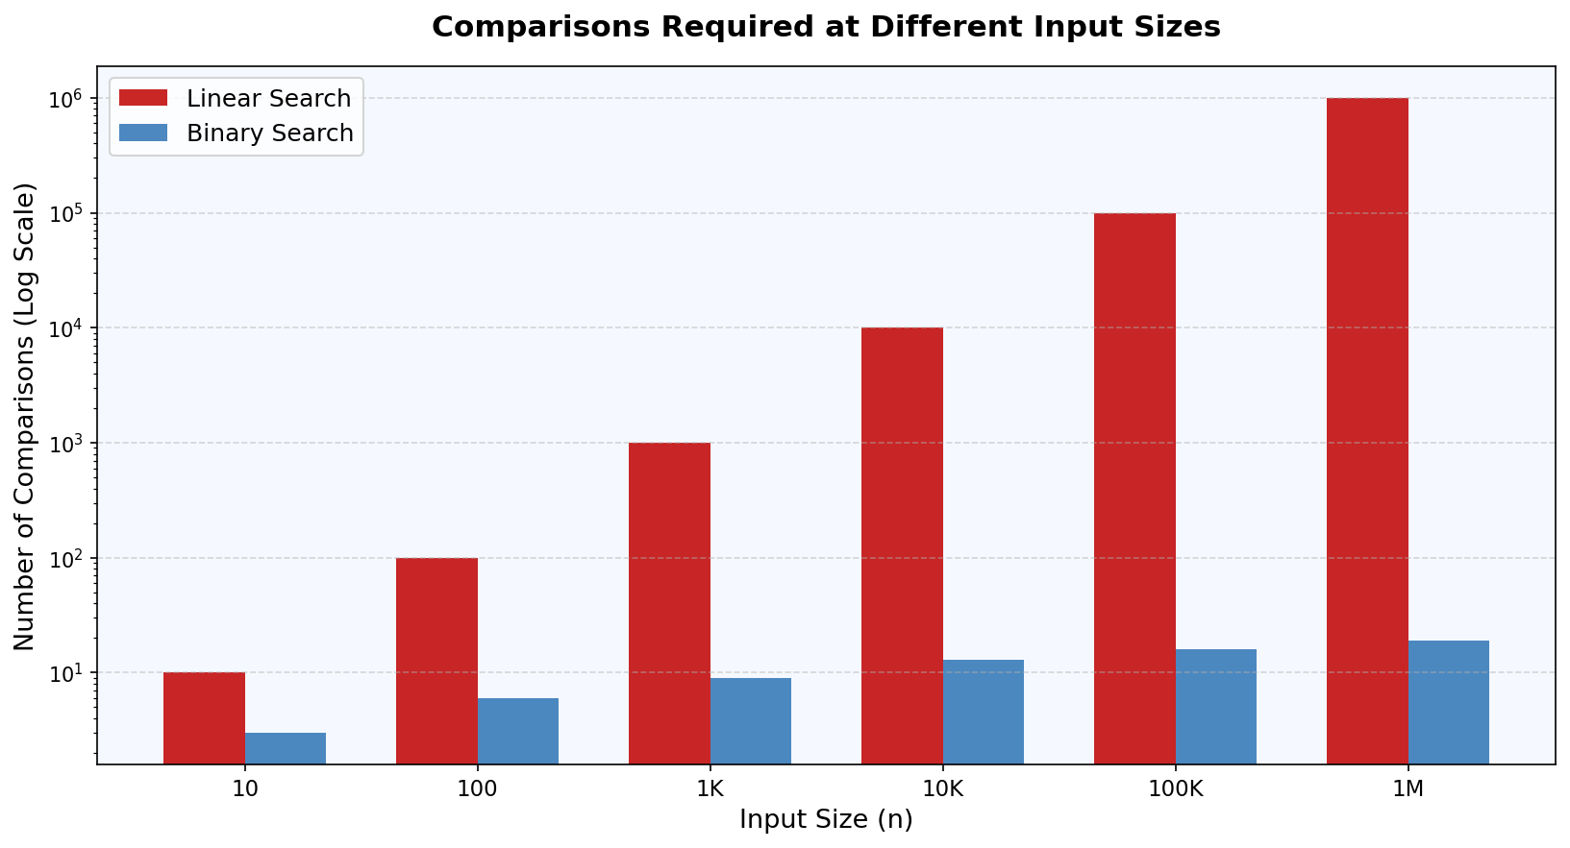
Fig 3: Bar chart comparison — comparisons required at each input size (log scale)

4.4 Best / Average / Worst Case (n = 1000)
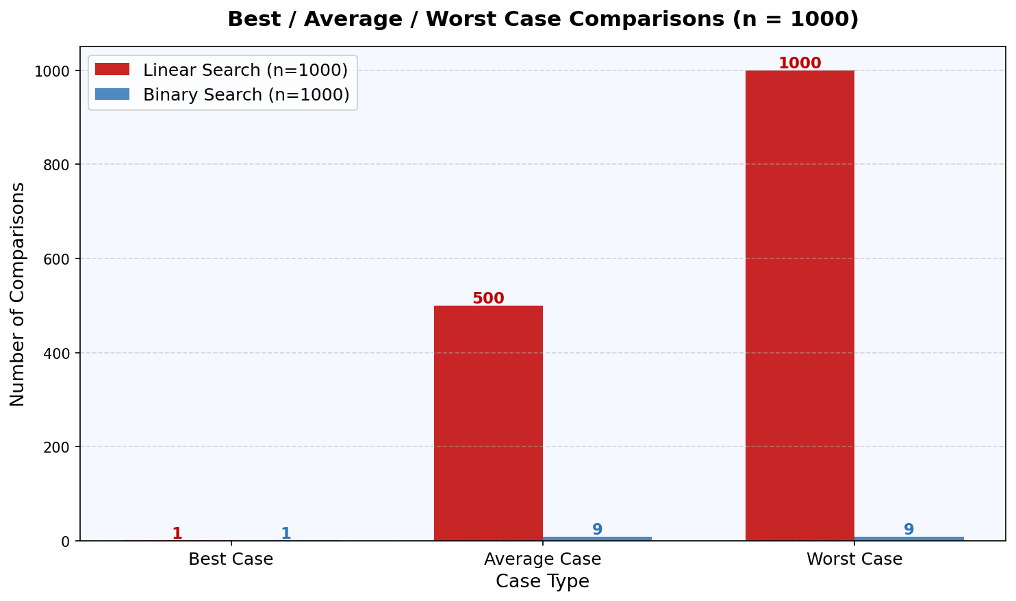
Fig 4: Case-wise comparison — Binary Search drastically outperforms in avg and worst cases

5. Head-to-Head Comparison

Parameter | Linear Search | Binary Search
Data Requirement | Unsorted / Sorted | Must be Sorted
Best Case | O(1) | O(1)
Average Case | O(n) | O(log n)
Worst Case | O(n) | O(log n)
Space Complexity | O(1) | O(1) / O(log n)
Implementation | Simple | Moderate
Performance on large n | Slow | Very Fast
Works on Linked List | Yes | No
Preferred For | Small / unsorted data | Large sorted datasets

6. Practical Use Cases

6.1 When to Use Linear Search
• Data is unsorted and sorting overhead is not justified.
• Dataset is very small (n < 50) where performance difference is negligible.
• Searching in a Linked List where random access is not possible.
• One-time search where sorting first would cost more time.
• Real-time systems where data is continuously changing.

6.2 When to Use Binary Search
• Data is already sorted or can be sorted once and searched many times.
• Large datasets where O(n) is too slow.
• Dictionary lookups, phone directory search, and database indexing.
• Finding insertion point in sorted arrays.
• Used in C++ STL functions like lower_bound() and upper_bound().

7. Conclusion

Both Linear Search and Binary Search are essential algorithms in a programmer's toolkit, each excelling in specific scenarios. Linear Search offers simplicity and works on any dataset regardless of order, making it ideal for small or unsorted data. Binary Search delivers exceptional performance for large sorted datasets due to its O(log n) time complexity.

The time graph analysis clearly demonstrates that Binary Search's logarithmic growth is vastly superior to Linear Search's linear growth as dataset size increases. At n = 1,000,000, Linear Search may need up to 1,000,000 comparisons, whereas Binary Search needs only 20 — a difference of 50,000x.

The choice between the two algorithms should always be guided by: the size of data, whether it is sorted, how frequently the search will be performed, and the available memory constraints.

— End of Document —

